# E-Auctioneer Management System

Step-1

Open the Project file folder and then copy e-auctioneer folder and paste in Xampp/htdocs/…

Step-2

Open **localhost/phpmyadmin** on your browser. Make a new database **eauctioneerdb** and import the database file.

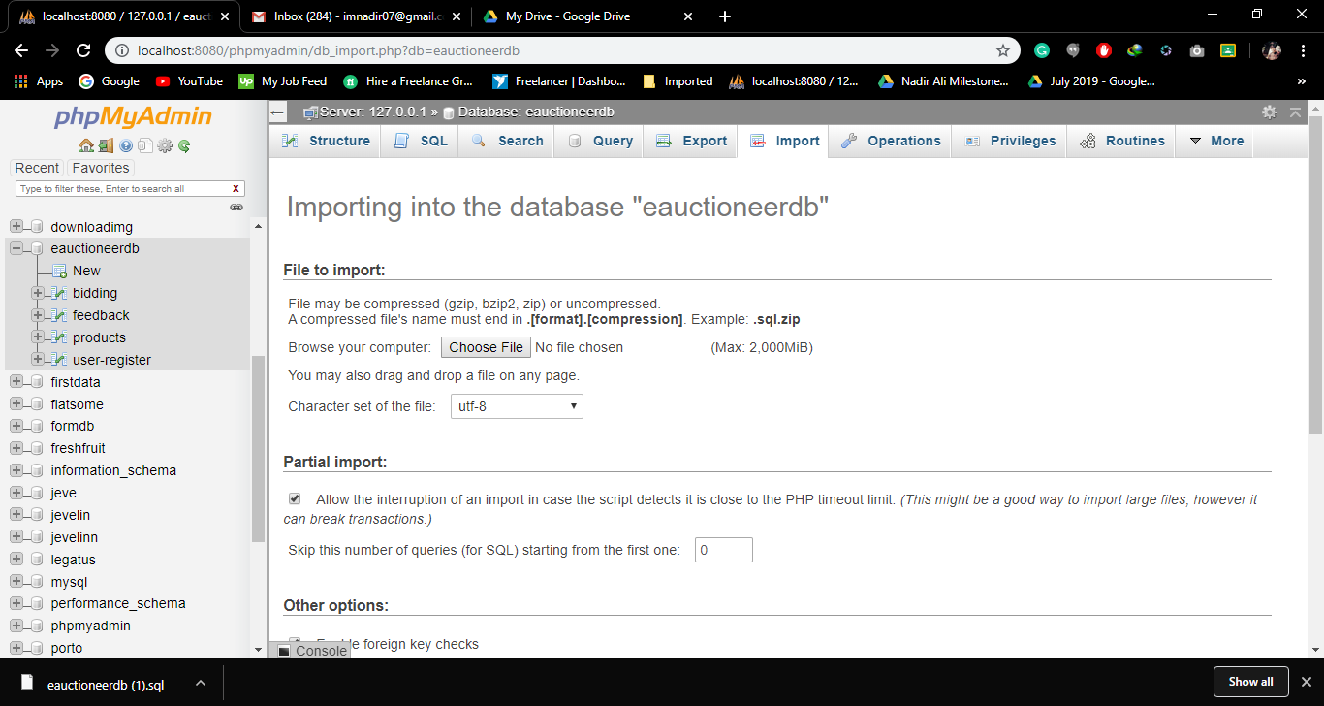

Step-3

When your database import successfully. Then go to your browser and type

**Localhost/e-auctioneer/.**